**Final Assignment:** Newsroom Portfolio Website Assignment Documentation

**Task 01: Header Implementation**

1. Use the **OOTB Header Component**.
2. Ensure the navigation menu includes the following pages:
   * Home
   * News
   * About Me
   * Contact Me
3. Implement a **drop-down menu** under "Books" where "News" should be listed.
4. Apply proper styling to maintain a visually appealing and consistent header.
5. Ensure the header is used at the **template level**, so it appears on all pages.

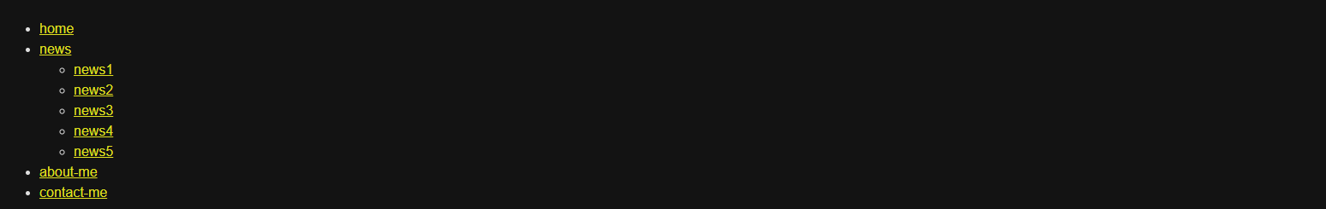

**Task 02: Footer Implementation**

The footer should include the following sections:

* **About Me** – A brief description of the journalist.
* **Contact Me** – Details to connect with the author.
* **Latest 5 News Articles** – List the five most recent news articles as hyperlinks that open in a new tab.
* **Social Media Links** – Links to social media profiles of the journalist.

The footer should also be **implemented at the template level**, ensuring it is displayed across all pages.

**Task 03: Home Page Implementation**

1. Use the **OOTB Teaser Component** to display an award ceremony for a journalist.
2. Author the teaser component with:
   * **Image**
   * **Title**
   * **Short Description**
   * **Call-To-Action (CTA)** linking to a dedicated page where the full award-related news is displayed.

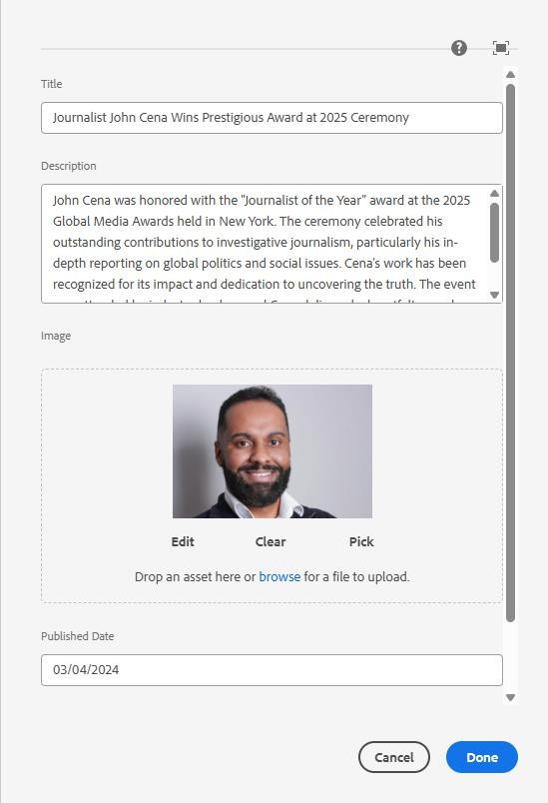

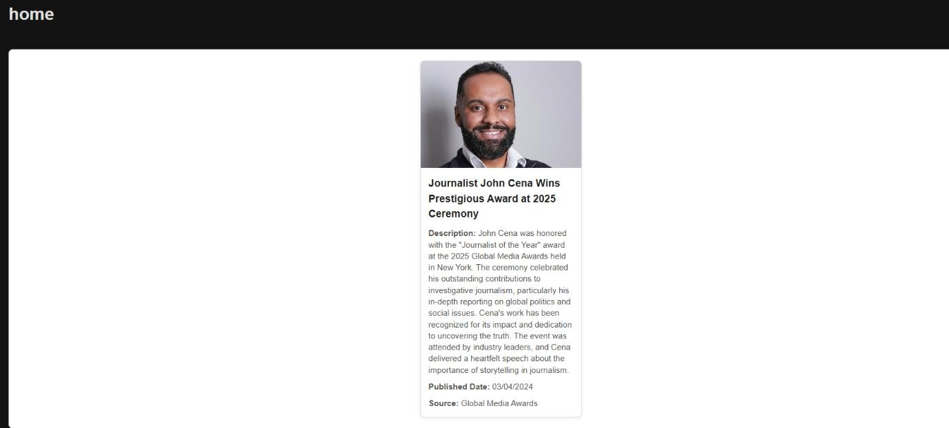

**Task 04: News Page Implementation**

1. **Create a NewsRoom Component**:
   * This component should fetch and display news articles stored under

/content/news.

1. **Create the News Page**:
   * Author it as the parent page where the NewsRoom component will be placed.
2. **News Articles**:
   * Create individual news article pages under /content/news.
   * Each news article page should be authored with:
     + **Title**
     + **Image**
     + **Text**
   * Ensure the NewsRoom component retrieves and displays each news article as a card, with:
     + **Unique Title**
     + **News Detail**
     + **Image**

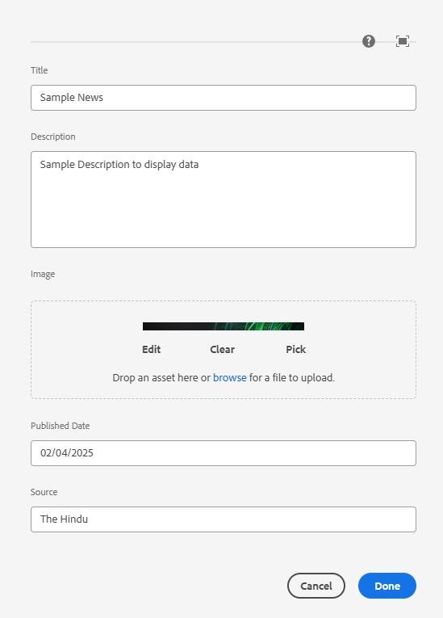

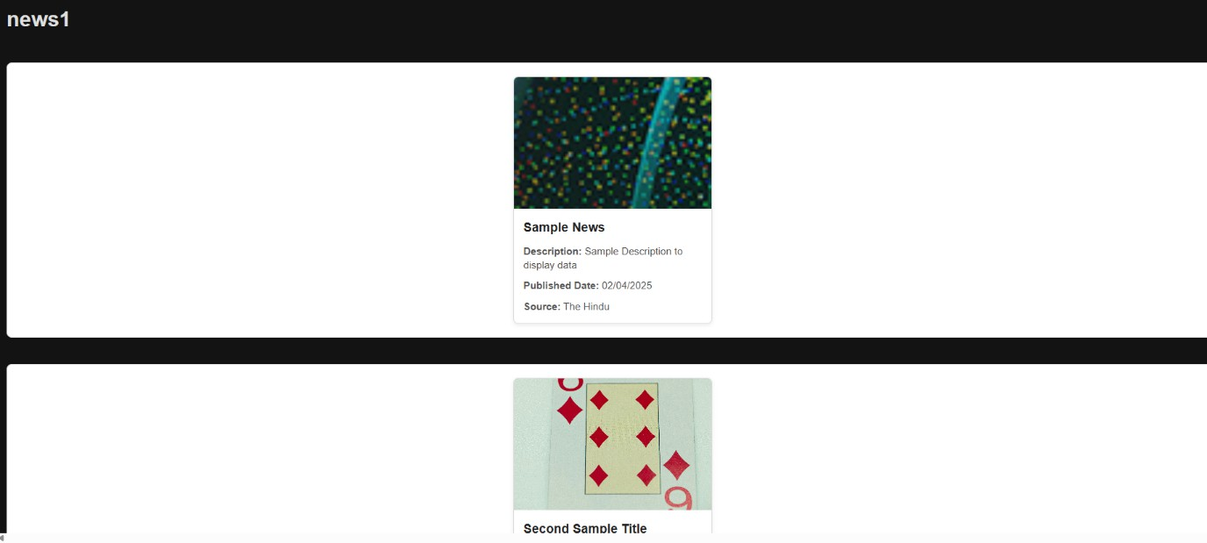

**Task 05: About Me Page Implementation**

1. Use the **Journalist Component** to provide information about the journalist.
2. Do not use any other components on this page.
3. Ensure the content is structured properly to present the journalist's background effectively.

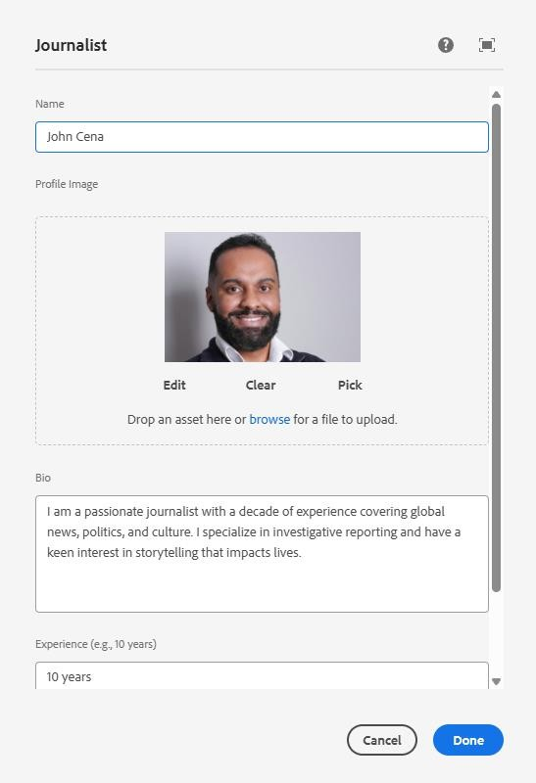

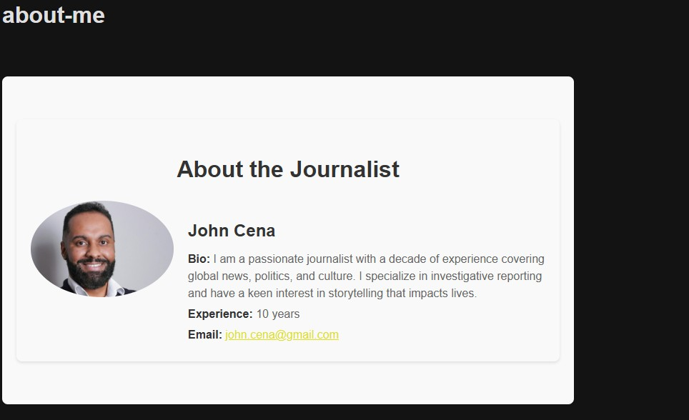

**Task 06: Contact Me Page Implementation**

1. Use either the **Text Component** or the **Teaser Component** to display contact details.
2. Include:
   * **Email or phone number** for direct communication.
   * **Links to social media profiles**, allowing users to follow the journalist.

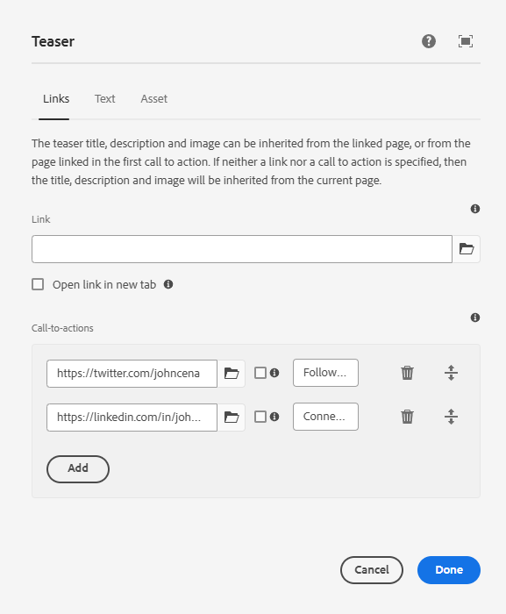

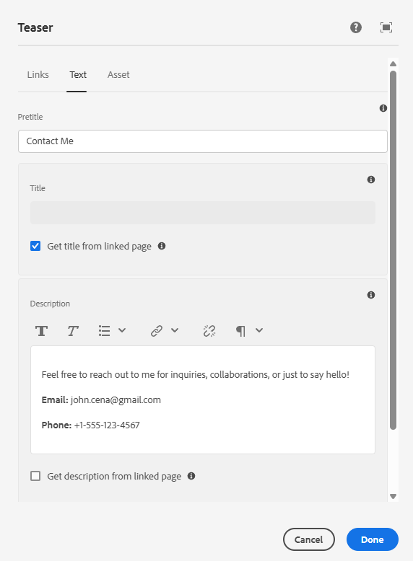

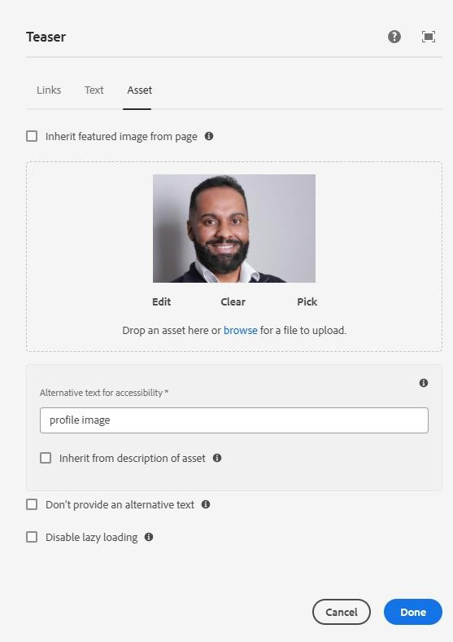

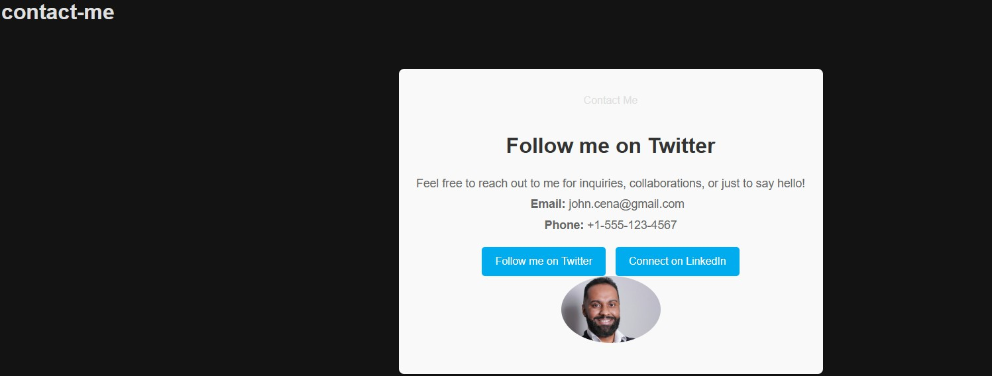

**Template Usage**

* **Home Page** – Use the **OOTB Content Page Template**.
* **Books Page** – Use the **Book Page Template** (provided as part of the assignment).
* **Ensure the Header and Footer are implemented at the template level**, so they appear consistently across all pages.

Code:

CSS for style:

@import "variables";

@import "base";

@import "../components//*.scss";

@import "./styles/*.scss";

.newsitem {

width: 300px;

background-color: #fff;

border: 1px solid #ddd;

border-radius: 8px;

box-shadow: 0 2px 6px rgba(0, 0, 0, 0.08);

overflow: hidden;

margin: 20px auto;

display: flex;

flex-direction: column;

}

.newsitem img {

width: 100%;

height: 200px;

object-fit: cover;

}

.newsitem-content {

padding: 15px;

display: flex;

flex-direction: column;

gap: 10px;

}

.newsitem-content h3 {

font-size: 1.2em;

color: #222;

margin: 0;

}

.newsitem-content p {

font-size: 0.95em;

color: #555;

margin: 0;

line-height: 1.4;

}

.newsitem-content a {

font-size: 0.9em;

color: #007bff;

text-decoration: none;

}

.newsitem-content a:hover {

text-decoration: underline;

}

.journalist {

max-width: 800px;

margin: 40px auto;

padding: 20px;

background-color: #f9f9f9;

border-radius: 8px;

box-shadow: 0 2px 4px rgba(0, 0, 0, 0.1);

}

.journalist h2 {

font-size: 2em;

margin-bottom: 20px;

text-align: center;

color: #333;

}

.journalist-content {

display: flex;

align-items: flex-start;

gap: 20px;

}

.journalist .profile-image {

max-width: 200px;

height: auto;

border-radius: 50%;

object-fit: cover;

}

.journalist-details {

flex: 1;

}

.journalist-details h3 {

font-size: 1.5em;

margin-bottom: 10px;

color: #333;

}

.journalist-details p {

margin: 5px 0;

color: #666;

}

.journalist-details p strong {

color: #333;

}

.cmp-teaser {

max-width: 600px;

margin: 40px auto;

padding: 20px;

background-color: #f9f9f9;

border-radius: 8px;

box-shadow: 0 2px 4px rgba(0, 0, 0, 0.1);

text-align: center;

}

.cmp-teaser__title {

font-size: 2em;

margin-bottom: 20px;

color: #333;

}

.cmp-teaser__description {

font-size: 1.1em;

color: #666;

margin-bottom: 20px;

}

.cmp-teaser__description p {

margin: 5px 0;

}

.cmp-teaser__description strong {

color: #333;

}

.cmp-teaser__image {

margin-bottom: 20px;

}

.cmp-teaser__image img {

max-width: 150px;

height: auto;

border-radius: 50%;

object-fit: cover;

}

.cmp-teaser__action-container {

display: flex;

justify-content: center;

gap: 15px;

flex-wrap: wrap;

}

.cmp-teaser__action-link {

display: inline-block;

padding: 10px 20px;

background-color: #00aced;

color: white;

text-decoration: none;

border-radius: 5px;

transition: background-color 0.3s;

}

.cmp-teaser__action-link:hover {

background-color: #0087b4;

}

.footer {

background-color: #1a1a1a;

color: white;

padding: 20px;

display: flex;

justify-content: space-between;

flex-wrap: wrap;

}

.footer-section {

width: 24%;

}

.footer-section h3 {

border-bottom: 2px solid #f39c12;

padding-bottom: 5px;

margin-bottom: 10px;

}

.footer-section ul {

list-style: none;

padding: 0;

}

.footer-section ul li {

margin: 5px 0;

}

.footer-section ul li a {

color: #f39c12;

text-decoration: none;

}

.footer-section ul li a:hover {

text-decoration: underline;

}

@media (max-width: 768px) {

.footer {

flex-direction: column;

text-align: center;

}

.footer-section {

width: 100%;

margin-bottom: 15px;

}

}

newsitem.html

<div class="newsitem">

  <img

    data-sly-test="${properties.fileReference}"

    src="${properties.fileReference}"

    alt="${properties.title}"

  />

  <div class="newsitem-content">

    <h3>${properties.title || 'No Title'}</h3>

    <p>

      <strong>Description:</strong>

      ${properties.description || 'No Description'}

    </p>

    <p>

      <strong>Published Date:</strong>

      ${properties.publishedDate || 'Not Available'}

    </p>

    <p>

      <strong>Source:</strong>

      ${properties.source || 'Not Available'}

    </p>

  </div>

</div>